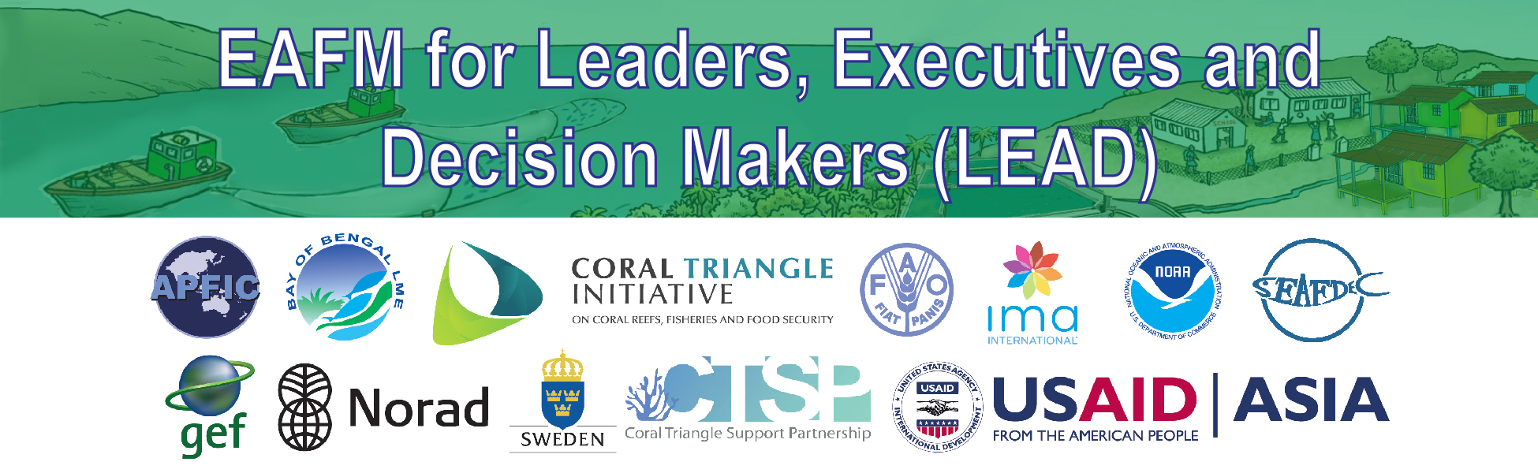
A2: Conversation

“Hot news” and the LEAD course
PURPOSE
To have better engagement and understanding between the LEAD Course provider and the LEAD course participants in each country.
“Hot news” will
- Allow LEAD course providers to be aware of and able to discuss key current issues related to EAFM with decision makers(ministers/secretaries/LEAD course participants)
- Help LEAD course delivery for that country by linking these key issues to the courses and allowing course providers to prepare in advance.
The hot-news helps the LEAD course provider to understand better the context and issues for the participants. When the LEAD provider talks to them in the course, they might raise these problems for concerns. When we are briefing decision makers (ministers/secretaries/LEAD course participants) about LEAD and EAFM knowing the key issues in advance will help “sell” EAFM packages. It helps us to prepare and get win-win situation when we already prepared what the answer and link to EAFM. Also help to improve LEAD course more effective.
The examples below are for “hot-news” collected in many countries to help understand each country problem in fisheries. Sources can be personal contact, the press or government reports.
SOURCES OF HOT NEWS
- Hot news changes regularly
- It is recommended that” hot news” should cover the process by which news can be collected prior to any LEAD course.
- Hot news can often be found by an internet search of fisheries keywords for a certain country.
  - Examples of keywords that can quickly yield some hot news for a country are: fish; fisheries; fishing; fishers; illegal; ban; over fishing; impacts; management; trade etc.
- Hot news may not cover a major long term problem such as overfishing/over-capacity, unless it is becoming a political topic. This means that some serious underlying issues may not be in the news.

SOME COUNTRY LEVEL EXAMPLES OF “HOT ISSUES”
Human Well-being
Thailand | Migrant fishing; trafficking of fishers; labour issues on fishing vessels  Trafficking of fisherman in Thailand (Action plan and implementation the DoF addressing Labour issues and promoting better working conditions in Thai fisheries industry)

Ecological well-being
Bangladesh | Declaration of new (5th) Hilsa Sanctuary  The first time Government of Bangladesh declared close season for fishing by industrial trawler. The period is from 20 May to 23 July each year total 65 days
Indonesia | Prohibition of the use of trawling  The next issue is the prohibition of the use of trawling in all Indonesian regions, moratorium on catching fish for the former, permitting foreign vessels (including many vessel from Thailand), the prohibition of transhipment of the catch of fish in the sea, and
 | Conservation of Endangered, Threatened, and Protected (ETP) species The related IUU issues of conservation and endangered fish, especially turtle and shark and live reef fish.
India | Controversy over permits to foreign fishing vessels in the deep sea zone  Controversy on the Report of the Expert Committee( headed by Dr Meenakumari) Constituted for Comprehensive Review of the Deep Sea Fishing Policy and Guidelines- fear of foreign and big domestic fishing industry taking over deepsea fishing, controversy on a new buffer zone suggested between 200m and 500 m depth and non-involvement of many fishing stakeholders in the decision making
Malaysia | Consideration of prohibiting trawling  Malaysia is considering a trawl ban starting next year 2016.
Maldives | Certification for pole-and-line caught tuna  Marine Stewardship Council (MSC) certification for the pole and line fishing of Tuna in Maldives (one year old positive story).

Governance
Bangladesh | Lengthy process to confirm participation in IOTC as Cooperative Non-Contracting Party  At the 12th Session of the Compliance committee of IOTC held in Busan, Korea. Bangladesh became a Cooperating Non-Contracting Party (CNC).
Measures introduced to limit impact of industrial fisheries
First-time declaration of “closed season” for industrial trawling
India | Transboundary fishing: trawling in Sri Lankan territorial waters (Palk Bay, Gulf of Mannar)  Indian trawler fishermen often cross into Sri Lankan territorial waters for fishing following which they are arrested and their boats are confiscated.
Enforcement of fishing ban (closed season)
Extension of the 45 days fishing ban on east coast and west coast to 61 days
Indonesia | Illegal, unreported and unregulated (IUU) fishing  Foreign vessels dual flagged vessels and weak governance of the process of reflagging.
 | Enforcement of the prohibition of transhipment
Malaysia | Illegal, unreported and unregulated (IUU) fishing  IUU fishing. Malaysia have detained a suspected IUU foreign fishing vessel Perlon in Waters off Johor. Thus is the result of regional effort among the RPOA IUU member countries as part of their effort to combat IUU fishing.
Myanmar | Illegal, unreported and unregulated (IUU) fishing by foreign vessels
Sri Lanka | EU ban of fisheries imports due to IUU fishing  EU Red card for IUU
Transboundary fishing by Indian trawlers (Palk Bay)
Indian trawler fishermen often cross into Sri Lankan territorial waters for fishing following which they are arrested and their boats are confiscated.
Thailand | Outdated and inadequate legal frameworks or fisheries legislation; considerable time requirements in passing new legislation  EU issues yellow card to Thailand over illegal fishing (IUU). Thailand has expressed deep disappointment after the European Union (EU) issued a final warning, a so-called "yellow card" to the country, and gave Thailand six months to drastically improve measures against IUU.

